Relatório LAPR5



Instituto Superior de Engenharia do Porto – Janeiro 2025

Grupo 51

Gonçalo Costa – 1220897

Gonçalo Ribeiro- 1220702

Guilherme Pinto – 1221074

José Sá - 1220612

Contents

7.6.1 Download Medical History 3

7.6.2 Deletion of Personal Data (Patient) 4

7.6.3 & 7.6.4 Privacy Policy 5

User Data Usage 5

What data is processed? 5

How is the data processed? 5

What are your rights under the GDPR 6

How long will we keep your data? 6

# 7.6.1 Download Medical History

For this User Story, we were asked the following: “As a Patient, I want to download my medical history in a portable and secure format, so that I can easily transfer it to another healthcare provider.”.

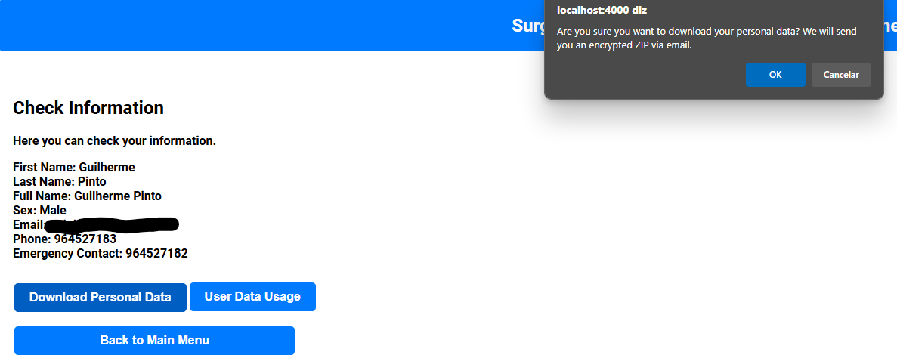Here we decided the best way to download the patient medical history was through the email sending of an encrypted file. That way we add a layer of protection to the data of the patient. We also decided the best way to guarantee a good and safe password for the patient was to include in the password the patient NIF number.

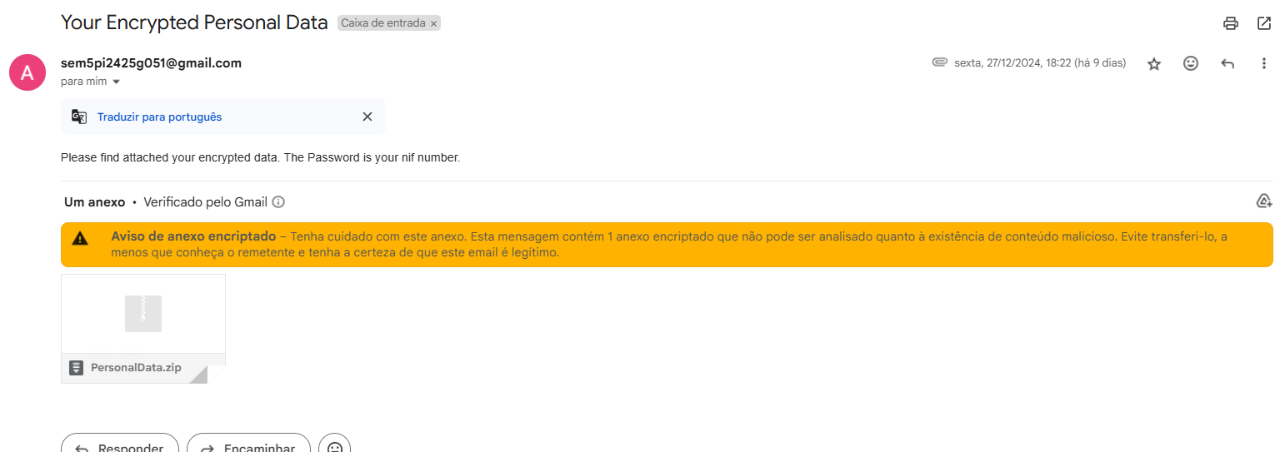_____________________________________________________________________

# 7.6.2 Deletion of Personal Data (Patient)

For this User Story, we were asked to do this: “As a Patient, I want to request the deletion of my personal data, so that I can exercise my right to be forgotten under GDPR.”.

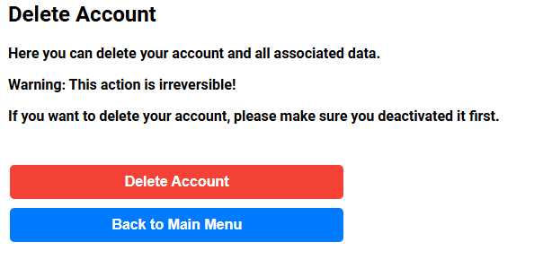

After the deleted account you will not be able to sign-in and we decided to keep the user inactive for a period of 30 days before completely removing the user from the system

# 7.6.3 & 7.6.4 Privacy Policy

Finally, for the last two User Stories we were asked to do the following: “As a Patient, I want to know what data will be processed, in what manner, and how I can exercise my rights.” & “As a Patient, I want to know for how long my personal data will be kept.”.

This is well presented at ur website as well.

## User Data Usage

We value your privacy and are commited to providing clear information about how your personal data is handled in compliance with the General Data Protection Regulation (GDPR). Below, we explain what data is processed, how it is processed, your rights under the GDPR and how long we will keep your data.

## What data is processed?

We process the following data:

* First Name
* Last Name
* Full Name
* Birth Date
* Sex
* Email
* Phone Number
* Emergency Contact
* Medical Record (allergies and medical conditions)
* Medical History

## How is the data processed?

We process your data for the following purposes:

* Providing medical care and treatment
* Administrative tasks, such as scheduling appointments
* Providing you with access to your own data
* Compliance with legal and regulatory requirements

All data processing activities are carried out in accordance with the General Data Protection Regulation (GDPR), ensuring that your data is processed securely and confidentially while respecting your rights.

## What are your rights under the GDPR

Under the GDPR, you have the following rights regarding your personal data:

* Right to access (Article 15): You can request a copy of your personal data and supplementary information.
* Right to rectification (Article 16): You can ask us to correct inaccurate or incomplete data.
* Right to erasure (Article 17): You can request the deletion of your data, subject to legal requirements.
* Right to restriction of processing (Article 18): You can limit how your data is used in certain circumstances.
* Right to data portability (Article 20): You can request your data in a structured, machine-readable format to transfer to another controller.

You can request a copy, an update and the deletion of your personal data in your user page.

If you have any question on how to exercise your rights, please contact our staff team. We will respond to your request promptly and in compliance with GDPR timelines.

## How long will we keep your data?

While you are a registered user, we will keep your data for as long as necessary to provide you with medical care and treatment, as well as to comply with legal and regulatory requirements, or for 5 years after the last patient interaction. After this period, your data will be securely deleted. If you deactivate your account, your data will be kept for a period of 30 days. After this period, your data will be securely deleted.

If you have any questions or concerns about how your data is processed, please contact our staff team. We are here to help and ensure that your data is handled securely and confidentially.